**Assignment:**

Write a shell script to perform log file rotation operation

**Conditions:**

* Rotate the log files based on either time or size
* Time based generation of log files can be done one file per day
* Size based generation of log files can be done when size >10MB
* Type of rotation and path of the log file should be obtained as positional parameters

**Script Execution:**

* Change directory to the script path
* Execute script as –

./LogRotate.sh <Type of rotation> <Absolute path to file>

Where,

Types of rotation :

1. Time base execution: timebased or -tb

2. Size based execution: sizebased or -sb

**Test Outcomes:**

* **Input scenarios –**

1. No input given then –

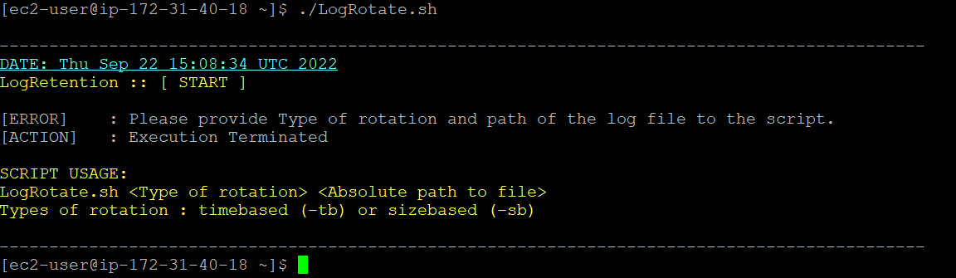

1. One input missing –
   1. If type missing –

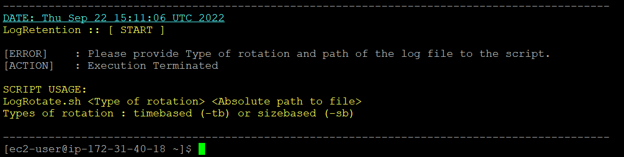

* 1. If path missing –

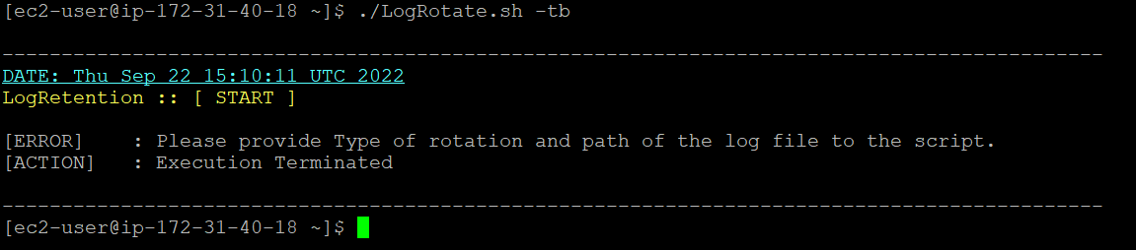

1. Wrong Type of rotation and correct path vise versa –

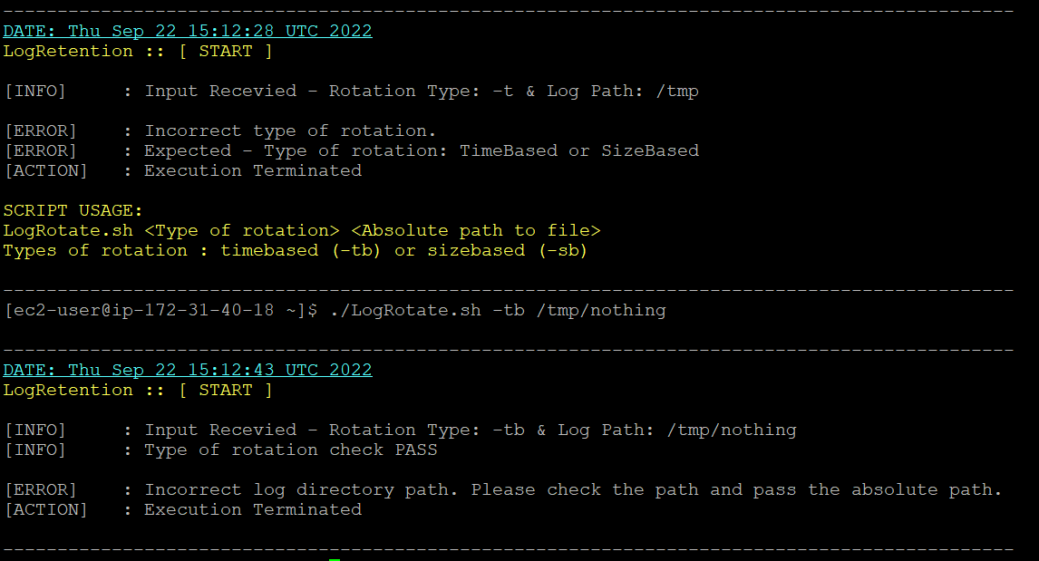

* **Size based –**

**Initial Structure (before executing script)–**

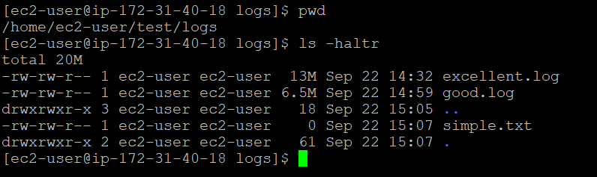

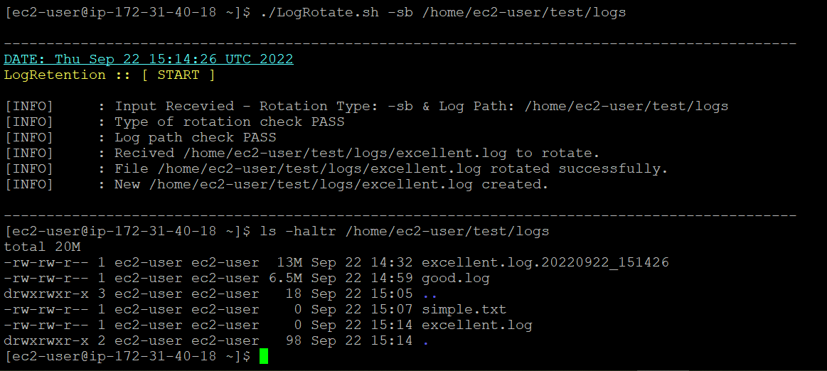

* **Time based –**

**Initial Structure (before executing script) –**

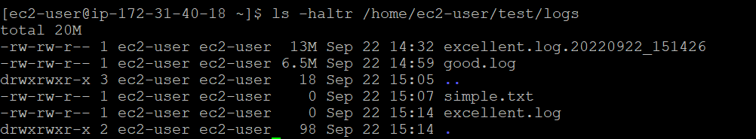

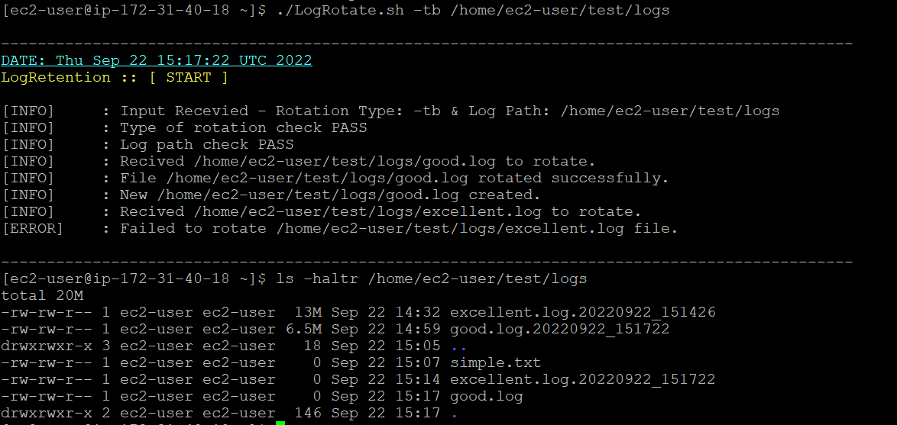

* Capturing everything into script log file as well –

